**TI BYTE Simulation Exercise**

**Week 4 : RC Circuits with Voltage Sources**

* **Question 1:**

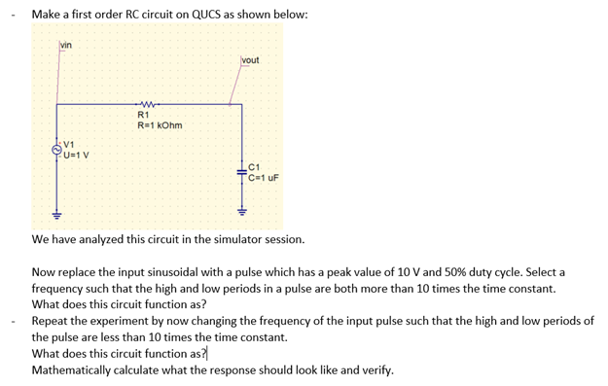

* **QUCS Circuits and Results:**

1. **Sinusoidal input:**

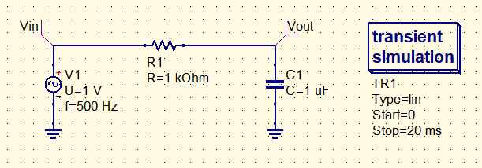

* The sinusoidal voltage source has an amplitude of 1 V and frequency of 1 Hz.

The waveforms of the circuit look like the following: 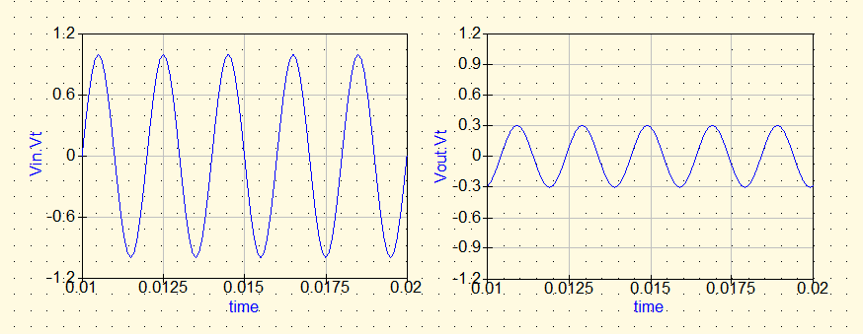

1. **Square input (τ > 10 RC):**

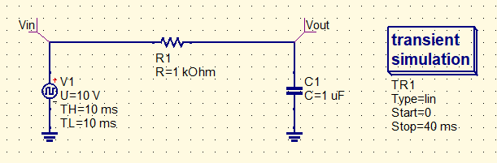

* The input sinusoidal voltage source is replaced with a pulse source with a frequency [evidently a square input].
* The square voltage source has an amplitude of 10 V and frequency of 50 Hz and 50% duty cycle. [Time period: 20 ms]
* The frequency is chosen such that the time period is more than 10 times the time constant of the circuit (1 ms).
* Thus, the capacitor has comparatively enough time to charge and discharge totally.
* The RC circuit, in the given circumstances, function as a Buffer, but with smooth rising and falling edges.
* The smoothness of the curve will depend on the ratio $t/τ$, higher the ratio, less smooth is the curve and vice versa.

The waveforms of the circuit look like the following:

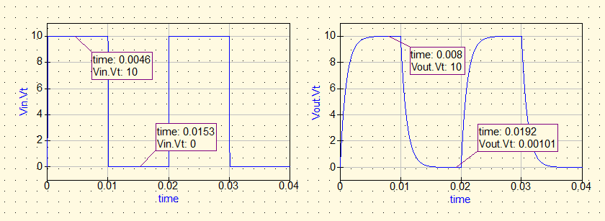

* + **Calculations:**

We have, Vin = +10 V,

We know that the charging-discharging eqn. of the capacitor is:

$$V_{c}\left(t\right)=V_{f}+(V_{i}-V_{f})e^{{-t}/τ}$$

where $V_{f}$ is the final voltage, $V_{i}$ is the initial voltage and $τ$ is the time constant = RC = 1 ms.

For my circuit, the TH of the pulse is comparatively high (= 10 ms) and thus the capacitor will fully attain the steady state value which is 10 V, during this time. The calculations can be shown as follows:

Vf = 10V, Vi = 0V and $τ$ = 1ms.

So, output capacitor voltage after 10 ms,

Vc(t) = [10+(0-10) $e^{\frac{-10}{1}}$]

= 10(1- $e^{-10}$) ≈ 10 V

Similarly for the TL for the pulse, the capacitor will discharge completely through the resistor, as:

Vf = 0V, Vi = 10V and $τ$ = 1ms.

So, output capacitor voltage after 10 ms,

Vc(t) = [0+(10-0) $e^{\frac{-10}{1}}$]

= 10 $e^{-10}$ ≈ 0 V

Thus we can verify that the simulated output goes in accordance to the mathematically derived equation, and that, this circuit acts as a smooth buffer.

1. **Square Input (τ < 10 RC):**

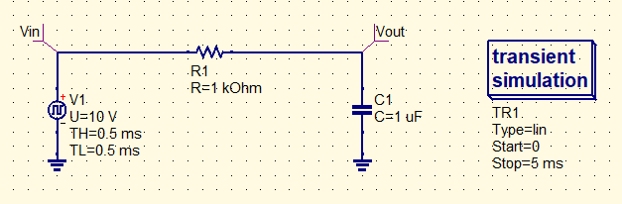

* The input sinusoidal voltage source is replaced with a pulse source with a frequency [evidently a square input].
* The square voltage source has an amplitude of 10 V and frequency of 1000 Hz and 50% duty cycle. [Time period: 1 ms]
* The frequency is chosen such that the time period is less than 10 times the time constant of the circuit (1 ms). [here, t = τ]
* Since the time constant is much higher as compared to the time period, the rise and fall time for the charging and discharging curves will be high.
* Thus, the exponential curves of charging and discharging can thus be approximated as linear increasing and decreasing curves, with a Vavg value of ${V_{peak}}/2$.
* The RC circuit, in the given circumstances, function as an Integrator, where the square waveform is transformed into a triangular waveform.
  + **Explanation:**

Since the capacitor charges very slowly, so for small values of t, all of the input voltage Vi will appear across the resistor. So, the current in the circuit will be

$$I\left(t\right)=\frac{V_{i}(t)}{R}$$

So, the output voltage across the capacitor,

$$V_{o}\left(t\right)= \frac{1}{C}\int{I\left(t\right)dt= \frac{1}{C}\int{\frac{Vi(t)}{R}dt=\frac{1}{RC}\int{Vi\left(t\right)dt } }}$$

The output is integrated version of the input voltage multiplied by a constant value.

* + **Calculations:**

We have, Vin = +10 V,

We know that the charging-discharging eqn. of the capacitor is:

$$V_{c}\left(t\right)=V_{f}+(V_{i}-V_{f})e^{{-t}/τ}$$

where $V_{f}$ is the final voltage, $V_{i}$ is the initial voltage and $τ$ is the time constant = RC = 1 ms.

* Now, for the first TH time of the first cycle,

the voltage across the capacitor can be calculated as,

Vf = 10 V, Vi = 0 V and $τ$ = 1ms, TH = 0.5 ms,

Vout(t) = [10+(0-10) $e^{\frac{-0.5}{1}}$]

= 10(1- $e^{-0.5}$) ≈ 3.93 V

* After the first TL time, Vout can be calculated as,

Vf = 0 V, Vi = 3.93 V and $τ$ = 1ms, TL = 0.5 ms,

Vout(t) = [0+(3.93-0) $e^{\frac{-0.5}{1}}$]

= 3.93 $e^{-0.5}$ ≈ 2.38 V

* In the next TH of the next cycle,

Vf = 10 V, Vi = 2.38 V and $τ$ = 1ms, TH = 0.5 ms,

Vout(t) = [10+(2.38-10) $e^{\frac{-0.5}{1}}$]

= 10-7.62 $e^{-0.5}$ ≈ 5.37 V

* In the next TL,

Vf = 0 V, Vi = 5.37 V and $τ$ = 1ms, TL = 0.5 ms,

Vout(t) = [0+(5.37-0) $e^{\frac{-0.5}{1}}$]

= 5.37 $e^{-0.5}$ ≈ 3.26 V

* During the next TH,

Vf = 10 V, Vi = 3.26 V and $τ$ = 1ms, TH = 0.5 ms,

Vout(t) = [10+(3.26-10) $e^{\frac{-0.5}{1}}$]

= 10-6.74 $e^{-0.5}$ ≈ 5.91 V

* It can also be shown that at the final steady state response of the circuit can be equated, given that TH = TL,

The highest and the lowest peak value of the waveform are:

$$V_{H}= \frac{V}{2}\left(1+tanh⁡\left(\frac{T_{H}+ T_{L}}{4RC}\right)\right)$$

$$V_{L}= \frac{V}{2}\left(1-tanh⁡\left(\frac{T_{H}+ T_{L}}{4RC}\right)\right)$$

For our case, TH = TL = 0.5 ms, RC = 1 ms,

∴, VH = 5 × (1 + tanh (0.25)) = 5 × (1 + 0.2249) = 6.224 V

and, VL = 5 × (1 - tanh (0.25)) = 5 × (1 - 0.2249) = 3.775 V

and, the average value of the triangular waveform is = ${V_{in}}/2$ = 5 V

The waveforms of the circuit look like the following:

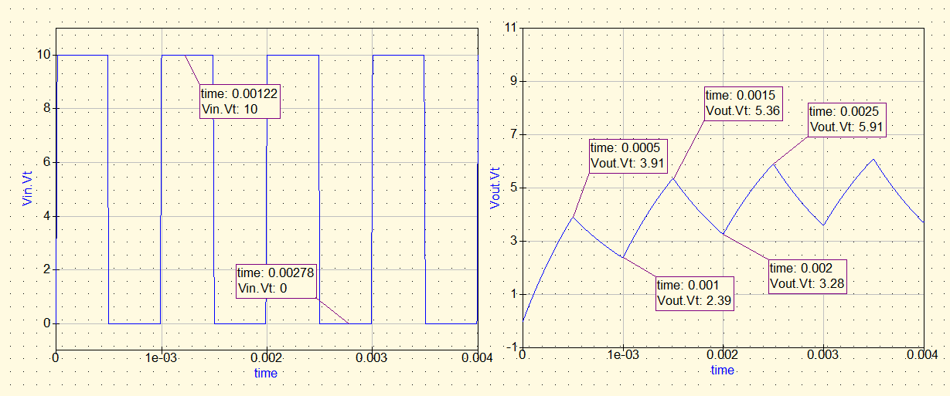

* **Conclusion:**

The simulation result almost matches with our calculations. The slight difference in the values is because the input pulse is not an ideal one and there is some very small finite rise and fall times. Hence the TH and TL are not perfectly 1 ms. The output is approximately a triangular wave.

* **Question 2:**

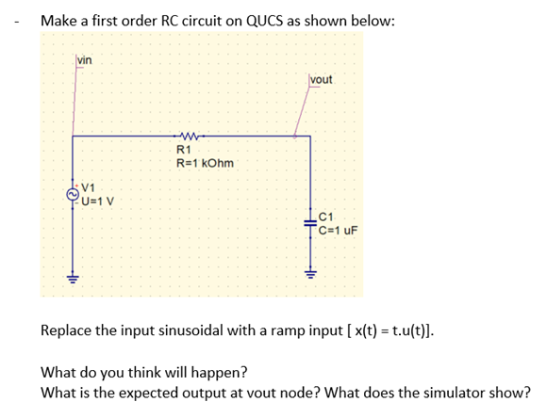

* **QUCS Circuits:**

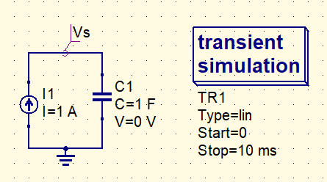

**Fig 1. V ramp.sch**

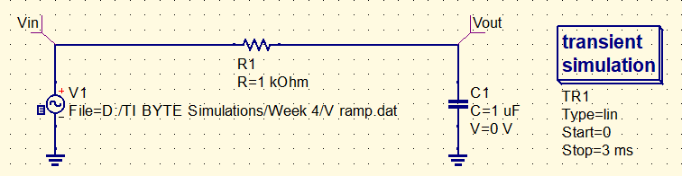

**Fig 2. QUCS circuit using file-based voltage source**

* The input sinusoidal voltage source is replaced with a ramp input source [x(t) = t × u(t)].
* Since ramp input source is not available, it is implemented using a file-based voltage source with the ramp voltage source implemented using a constant current source and a capacitor connected in series.
* The slope of the ramp voltage source (α) = 1
* **Expected Output:**
* Initially, the capacitor will resist a change in its voltage as finite current flows through the circuit.
* So, all the voltage will appear across the resistor and the current in the circuit will be due to the voltage drop across the resistor which is the whole input voltage.
* So, the output voltage across the capacitor,

$$V_{out}\left(t\right)= \frac{1}{C}\int{I\left(t\right)dt= \frac{1}{C}\int{\frac{Vi(t)}{R}dt=\frac{1}{RC}\int{Vi\left(t\right)dt } }}$$

Here, Vi(t) = αt, for t >0

So, $V_{out}\left(t\right)=\frac{α}{RC}\int_{0}^{t}{t dt}= \frac{{αt}^{2}}{2RC}$

* Now, slowly the capacitor will start charging ad the output voltage curve will be a parabolic one. (Integration of ramp)
* At steady state, capacitor behaves as an open circuit, so all of the voltage appears at the output and so at steady state, the output is a ramp with the same slope.
* So, the resultant output is a delayed ramp. This delay is given by αRC, where α is the slope of the ramp (here, 1).
* In this case, the delay is equal to the time constant = 1ms.

$$V_{out}= αt- αRC\left(1- e^{-t/{RC}}\right)$$

$$V_{out}= α\left(t- RC\right)+ αRC e^{-t/{RC}}$$

If τ >> RC, $V_{out} ≈ α\left(t- RC\right)$

* **QUCS Result:**

The output waveform of the RC circuit with a Ramp input using QUCS looks like the following,

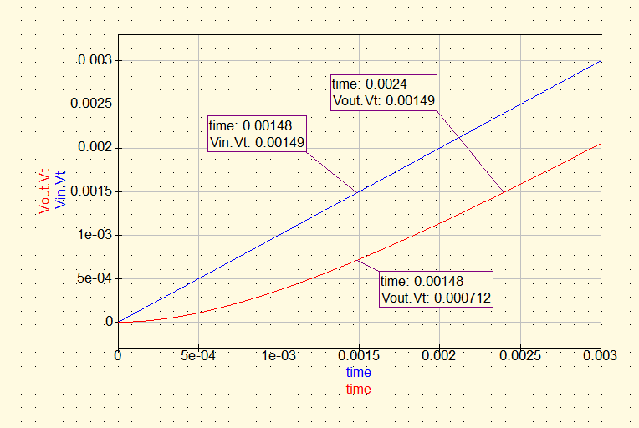

* **Conclusion:**
* From the simulation, we see that the output is initially following a parabolic curve and at steady state it attains a ramp state.
* Thus, the resultant output is a delayed ramp.
* Vin and Vout both attain 0.00149 V but the time delay is given by (0.0024 s - 0.00148 s) = 0.00092 s or 0.92ms, which verifies our calculation.